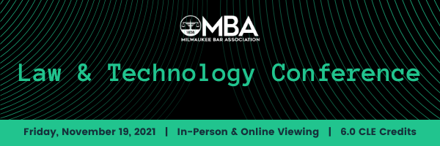
8:30 – 9:30 AM | Welcome  Keynote  Uuique Challenges of Managing Records at the White House  Phillip Droege, Director of White House Office of Records Managment
9:45 – 10:35 AM | BREAKOUT 1  Privacy in the Cloud  Galina  Datskovsky,  Vaporstreem | BREAKOUT 2  Manipulated Electronic Evidence: Stories from the Front Line of Digital Forensics  Erik K. Thompson, Date Narro
10:50 – 11:40 AM | BREAKOUT 3  Cybersecurity –  Legal Responsibilities  Kate Campbell and Sarah Sargent, Godfrey & Kahn, S.C. | BREAKOUT 4  Video Mediation Strategies  The Hon.  Richard  Sankovitz
11:55 – 1:00 PM | Table Talks
1:15– 2:05 PM | BREAKOUT 5  Cyber Liability Risks – What are they, what are the trends, and what is cyber liability insursance for law firms  Tom Watson and Matt Beier, WILMIC | BREAKOUT 6  PowerPoint  Paul Unger, Affinity Consluting
2:20 – 3:10 | BREAKOUT 7  Blockchain  Girish Ramachandra | BREAKOUT 8  Making the Most of  Your Software  Jeff Krause, Affinity  Consulting
3:25 – 4:15 | 25 Tips, Tricks…  Jeff Krause, Paul Unger, Olivia Kelley, Lars Larsen

